**POSSIBLE SUGESSTIONS IN TOP BOARD DESIGN – V3.3.**

**POINT NO. 1.**

Area of split plane (VCC_3V3_M) is small in PCB. It is better to increase its width.

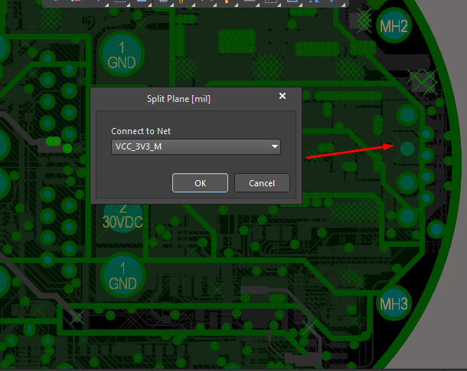

**POINT NO. 2.**

Copper Fill having VDD_3V3 net is somewhat close to main power rail (30VDC) in PCB. Having more gap between the two is recommended.

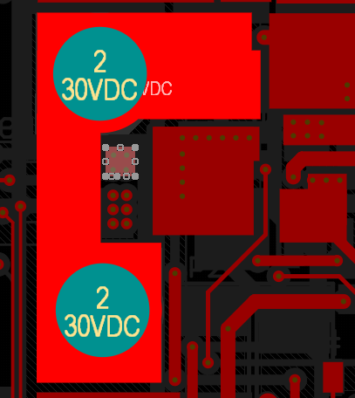

**POINT NO. 3.**

Better to add more ESD and TVS Diodes in the design. Currently only present in CAN signals. It should be implemented for Power rails and Motor Drivers signals too. As shown in image below.

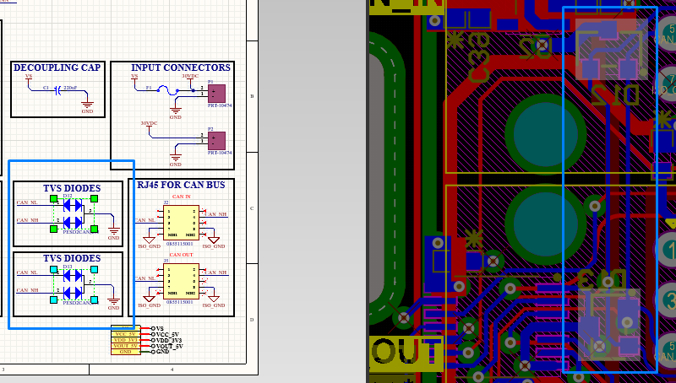

**POINT NO. 4.**

Isolators connections directions are correct but their power sides are mixed up in all isolator ICs.

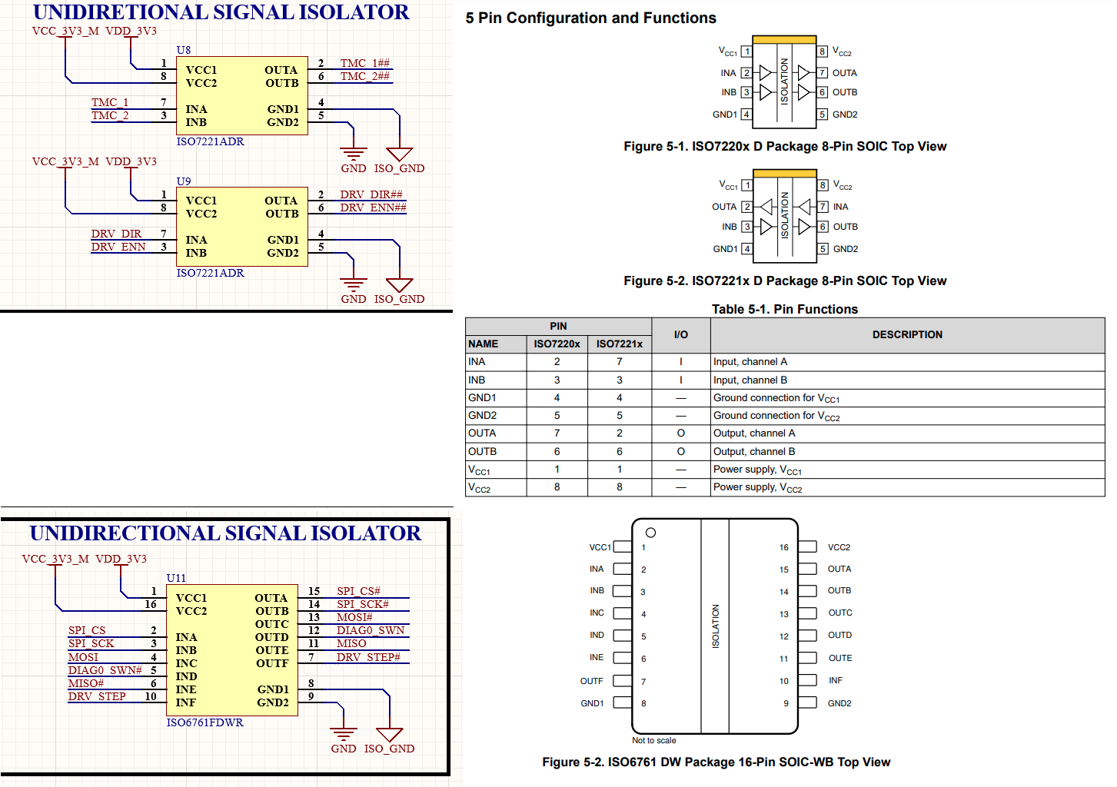

**POINT NO. 5.**

Isolator family should be upgraded to ISO77xx as recommended.

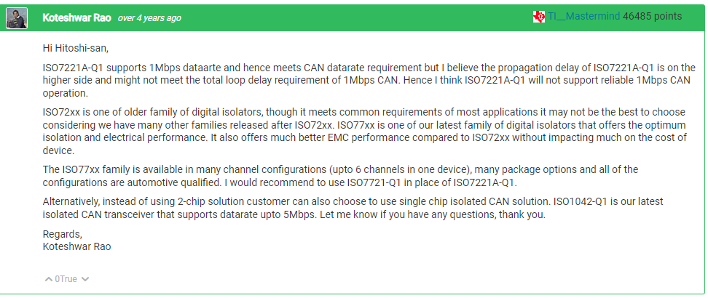

**POINT NO. 6.**

Observation on temperature Sensor PT100: The readings on net label **TEMP_OUT** were perfect and matched with the circuit formula. Observations can be checked [here](https://drive.google.com/drive/folders/1N1xB0ozvQ0e6G91vdsShQJjVPCLtAHLW?usp=sharing).

